**Lab 10- Integrating Tableau and R**

**R. Harini**

**18BCE1010**

**Dataset used:** PIMA Indians Diabetes

**R Script:**

SCRIPT_STR('library(rpart);

fit=rpart(Outcome~Age + Blood_Pressure + BMI + DPF + Glucose + Insulin + Pregnancies + Skin_Thickness, method="class",

data.frame(Age= .arg1, Blood_Pressure=.arg2,

BMI=.arg3, DPF=.arg4, Glucose=.arg5, Insulin=.arg6, Outcome=.arg7, Pregnancies=.arg8, Skin_Thickness=.arg9));

fit<-prune(fit, fit$cptable[which.min(fit$cptable[, "xerror"]), "CP"]);

t(data.frame(predict(fit, type="class")))[1,];',

AVG([Age]), AVG([Blood_Pressure]), AVG([BMI]), AVG([DPF]),

AVG([Glucose]), AVG([Insulin]), ATTR([Outcome]), AVG([Pregnancies]), AVG([Skin_Thickness])

)

**Visualization Graphs:**

BMI vs Age BMI vs Diabetes Pedigree Function

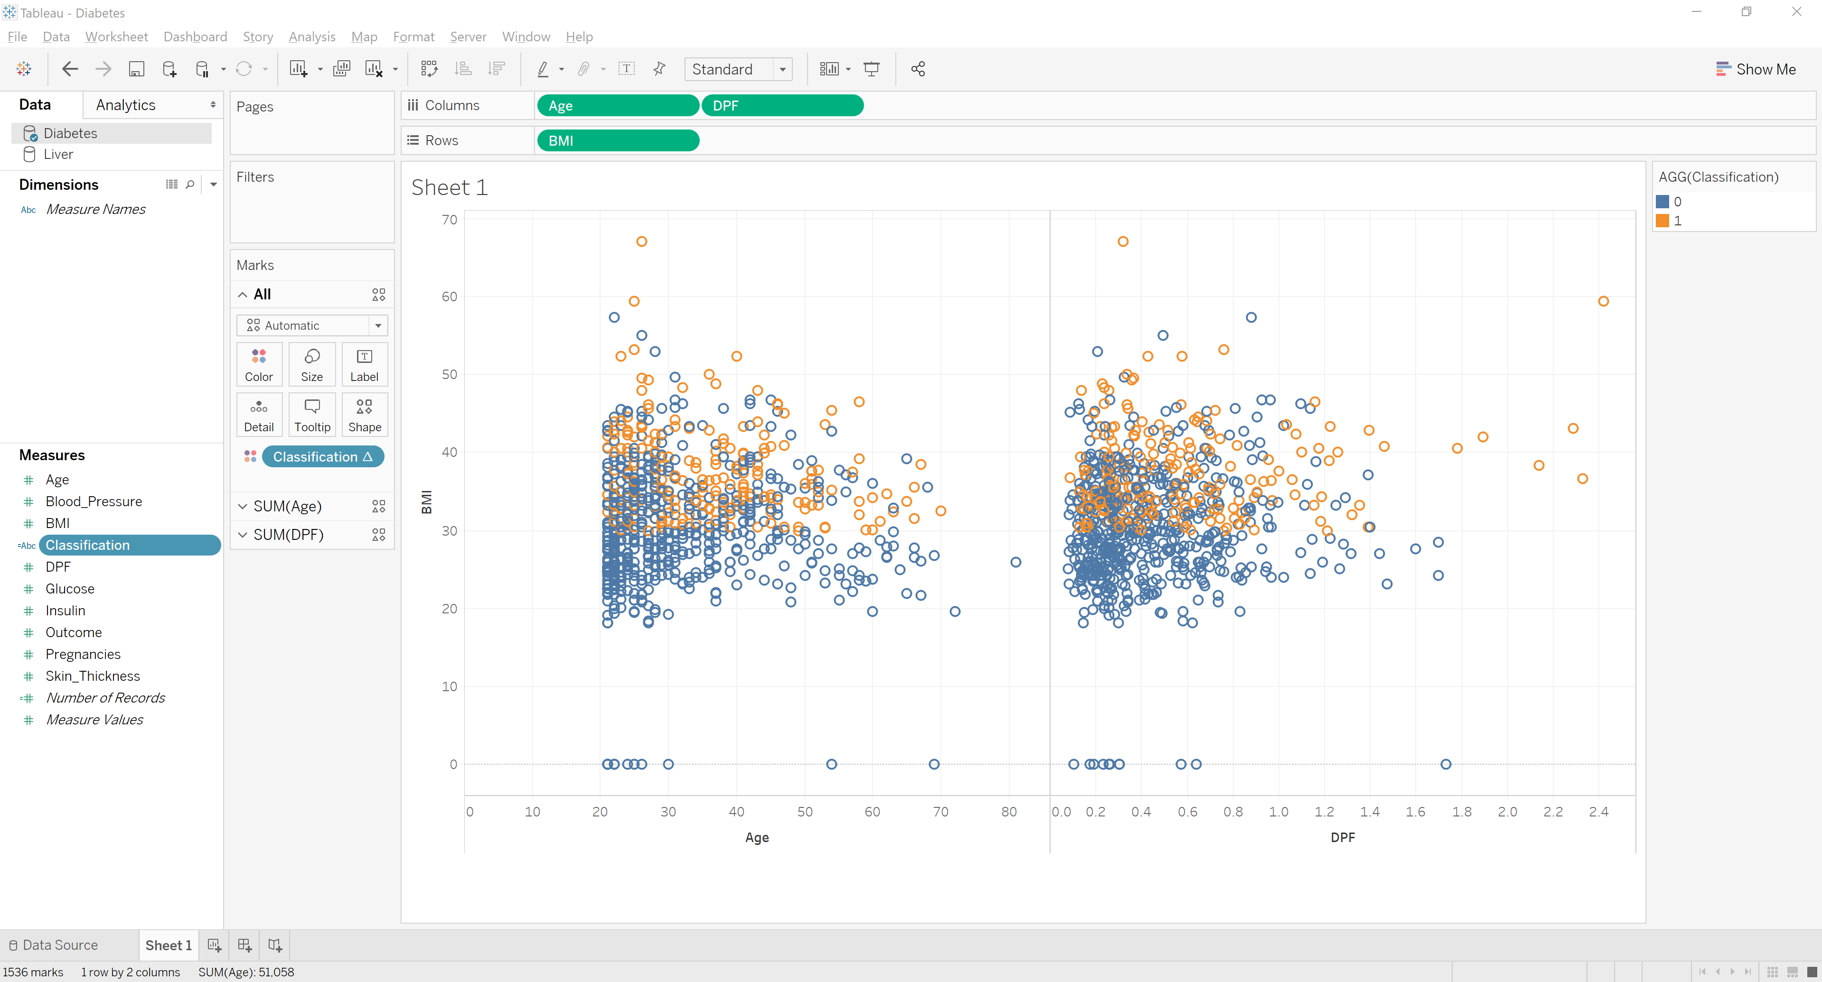

Insulin vs Age + Insulin vs DPF

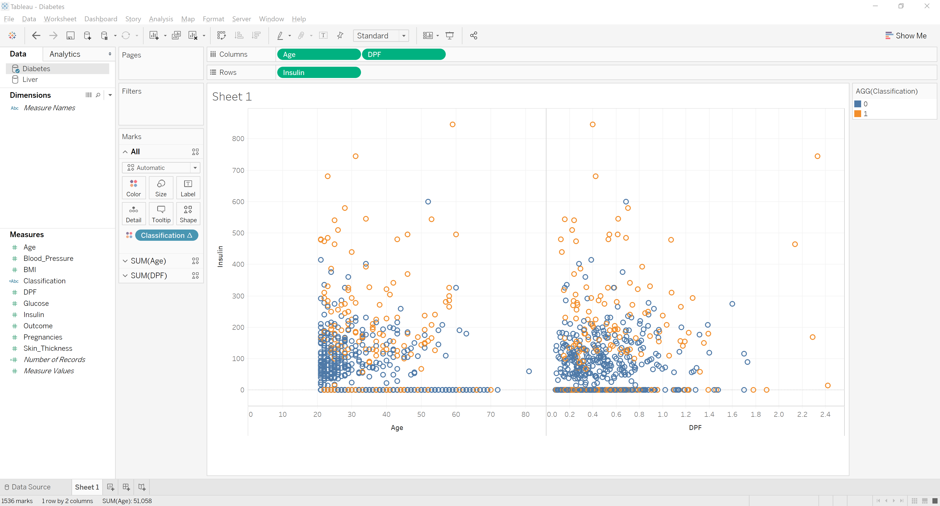

Pregnancies vs Age + Pregnancies vs DPF + Glucose vs Age + Glucose vs PDF

